 Statement and Confirmation of Own Work

|  |
| --- |
| ***A signed copy of this form must be submitted with every assignment.***  ***If the statement is missing your work may not be marked.*** |

Student Declaration

I confirm the following details:

|  |  |
| --- | --- |
| Candidate Name: | AMAAN AL MIR |
| Candidate ID Number: |  |
| Qualification: | L5DC |
| Unit: | Information Systems Analysis |
| Centre: | APTECH QATAR |
| I have read and understood both NCC Education’s *Academic Misconduct Policy* and the *Referencing and Bibliographies* document. To the best of my knowledge my work has been accurately referenced and all sources cited correctly.  I confirm that this is my own work and that I have not colluded or plagiarised any part of it. | |
| Candidate Signature: |  |
| Date: | October 30, 2023 |



**OPS020_dec16_Candidate+Statement+of+Own+Work.doc**

# Cover

Information Systems Analysis

VISOR INSURANCE

Assignment by

Amaan Al Mir

# Table of Contents

Cover 1

Table of Contents 2

Task 1 – Analysis (25 marks) 4

a) Different methods of information gathering 4

Explanation 5

Conclusion 13

b) Stakeholder Matrix 14

Task 2 – Ethics (10 marks) 16

Questions 16

Reasons 17

Task 3 – SWOT Analysis (30 marks) 18

a) Swot Analysis for Visor Insurance 18

Strengths 18

Weaknesses 19

Opportunities 20

Threats 21

b) Technical factors from weaknesses and threats 23

Weaknesses 23

Threats 27

Task 4 – User Requirements & Design (25 marks) 30

a. Claim Representatives Analysis 30

Characteristics and Requirements 30

Hierarchical Task Analysis 34

b. New Customer Account Interface 35

Task 5 (10 marks) 38

Description 38

Analysis 38

Action Plan 40

References 42

# Task 1 – Analysis (25 marks)

## Different methods of information gathering

|  |  |  |
| --- | --- | --- |
| Method | Advantages | Disadvantages |
| Interviews  (face-to-face) | In-depth insights | Time-consuming |
| Clarification | Bias |
| Non-verbal cues | Costly |
| Engagement | Limited scalability |
| Observation | Real-time insights | Limited context |
| Behavior patterns | Intrusive |
| Objective data | Time-consuming |
| Verification | Limited verbal insights |
| Documentation Sampling | Efficiency | Outdated information |
| Historical data | Incomplete documentation |
| Structured data | Lack of context |
| Consistency | Inaccuracy |
| Questionnaires (Paper and email) | Scalability | Superficial insights |
| Standardization | Bias |
| Cost-effective | Lack of clarification |
| Anonymity | Lack of responses |

### Explanation

#### Interviews (face-to-face)



Advantages:

* In-depth insights: Interviews allow direct communication, enabling a deeper analysis of employee roles and system requirements.
* Clarification: Interviewers can ask follow-up questions to clarify responses, ensuring accurate information is gathered.
* Non-verbal cues: Face-to-face interviews enable the observation of non-verbal cues, aiding in understanding employee emotions and concerns.
* Engagement: Face-to-face interviews can foster engagement and cooperation, making participants feel valued.

(Satzinger, et al., 2020)

Disadvantages:

* Time-consuming: Face-to-face interviews with many employees may take time, impacting efficiency.
* Bias: Interviews might introduce interviewer bias, leading to subjective data collection.
* Costly: Since Visor Insurance’s offices are located across the UK, travel costs and logistics associated with arranging face-to-face interviews can be expensive.
* Limited scalability: Face-to-face interviews might only be feasible for a few staff.

(Satzinger, et al., 2020)

#### Observation



Advantages:

* Real-time insights: Observing employees in their natural work environment provides accurate insights into their tasks and challenges.
* Behavior patterns: Observations reveal workflow patterns, helping to identify progress and productivity.
* Objective data: Observations offer objective data without relying on self-reporting, reducing potential biases in information gathering.
* Verification: Observations validate actual practices against documented procedures, highlighting any discrepancies.

*(Satzinger, et al., 2020)*

Disadvantages:

* Limited context: Observations might not capture all the contextual details that employees might not explicitly show during observations.
* Intrusive: Observations can be intrusive, making some employees uncomfortable.
* Time-consuming: Observations can require a lot of time to capture a representative range of activities of several employees.
* Limited verbal insights: Observations might not provide direct insights into employees' thoughts and rationales, unlike face-to-face interviews.

(Satzinger, et al., 2020)

#### Documentation Sampling



Advantages:

* Efficiency: Reviewing existing documentation can quickly provide an overview of roles and processes without disrupting work.
* Historical data: Documentation may offer insights into changes over time, helping to understand the evolution of roles and tasks.
* Structured data: Documentation provides structured information that can be easily referenced and compared for analysis.
* Consistency: Information gathered from documented sources is consistent and less influenced by individual biases.

(Satzinger, et al., 2020)

Disadvantages:

* Outdated information: Documentation might not accurately represent current practices due to lack of updates.
* Incomplete documentation: Some information might be incorrect or missing from the documentation.
* Lack of context: Documentation might lack context, making it challenging to fully grasp the system details.
* Inaccuracy: If the documentation is incomplete or inaccurate, it might lead to incorrect conclusions about the staff and the system.

(Satzinger, et al., 2020)

#### Questionnaires



Advantages:

* Scalability: Questionnaires can be distributed to several employees simultaneously, making them suitable for gathering extensive data.
* Standardization: Questionnaires ensure a consistent set of questions, reducing variability in data collection.
* Cost-effective: Email questionnaires eliminate travel costs and reduce logistical complexities.
* Anonymity: Participants can provide feedback without fear of repercussions, enhancing honesty in responses.

(Satzinger, et al., 2020)

Disadvantages:

* Superficial insights: Responses might be limited to predefined options, missing details and explanations.
* Bias: Employees might selectively respond or provide socially desirable answers, affecting data accuracy.
* Lack of clarification: Questionnaires cannot ask follow-up questions for clarification, leading to misinterpretation of responses.
* Lack of responses: Questionnaire response rates can be low, impacting the representativeness of the collected data.

(Satzinger, et al., 2020)

### Conclusion

Given the nature of Visor Insurance's operations, a combination of methods would be most effective. Interviews provide in-depth insights into staff roles and emotions, while observation captures real-time behaviors. Documentation offers historical data, and questionnaires ensure scalability. Considering the large number of employees and their distributed locations, a mix of observation, documentation sampling, and questionnaires (email-based) are recommended. These methods address the need for extensive data collection without causing excessive disruption to daily operations. Observation could be focused on critical tasks and interactions, documentation would help validate historical events, and questionnaires would aid in gathering broad opinions. This approach balances the advantages of various methods while minimizing their disadvantages.

(Satzinger, et al., 2020)

## Stakeholder Matrix

|  |  |  |
| --- | --- | --- |
| Stakeholder | Influence | Interest |
| Managing Director | High | High |
| Board of Directors | High | High |
| Call Center Manager | High | High |
| Call Center Line Manager | High | High |
| Claim Representative | High | High |
| Insurance Underwriter | High | High |
| Human Resources Personnel | Low | High |
| Administrative Staff | Low | Low |
| IT Team | High | High |
| Accountant | Low | Low |
| Customer Service Advisor (CSA) | Low | High |
| Customer (Individual and Business) | Low | High |
| Marketing Team | Low | High |
| Information Commissioner | High | High |

The placement of stakeholders in the matrix is based on their level of interest in the system changes and their level of influence over decision-making. Stakeholders with high interest and influence are likely to play a crucial role in shaping the new system, while those with high interest and low influence may require proper communication and engagement strategies. Those with low interest may need minimal involvement, and those with low influence must be kept informed to avoid potential concerns.

(Paul, et al., 2014)

High

High

Low

I N F L U E N C E

I N T E R E S T

(high influence, low interest)

Keep satisfied

(high influence, high interest)

Key players /

Manage closely

(low influence, low interest)

Monitor

(low influence, high interest)

Keep informed

# Task 2 – Ethics (10 marks)

## Questions

1. Knowledge: How confident do you feel using the Claims Management Information System (CMIS) to manage customer inquiries and claims?

2. Psychological: On a scale of 1 to 10, how often do you stress out while handling customers and their claims?

3. Task Structure: How well-defined are your tasks and responsibilities while assisting customers and processing claims within the CMIS?

4. Efficiency: How much has the current CMIS software impacted your efficiency in addressing customer queries and processing claims compared to the previous systems?

5. Ethical: How comfortable are you with accessing and managing customer data, ensuring privacy, and complying with data protection regulations?

## Reasons

1. Knowledge (System knowledge): This question determines CSA’s confidence in their system usage, aiming to understand how well the system's design supports their competence and knowledge.

2. Psychological (Emotional well-being): This question determines CSAs' emotional experience, addressing their psychological well-being and stress levels.

3. Task Structure (Workflow clarity): This question determines how well-defined tasks are, providing insights into whether the system design can be easily understood and operable.

4. Efficiency (System impact on workload): This question measures the impact of the system on CSA’s work efficiency, indicating how well the system supports their tasks and eases the workload.

5. Ethical (Data handling and privacy): This question addresses the ethical considerations of privacy and data protection of customers in the system.

(Valacich & George, 2022)

# Task 3 – SWOT Analysis (30 marks)

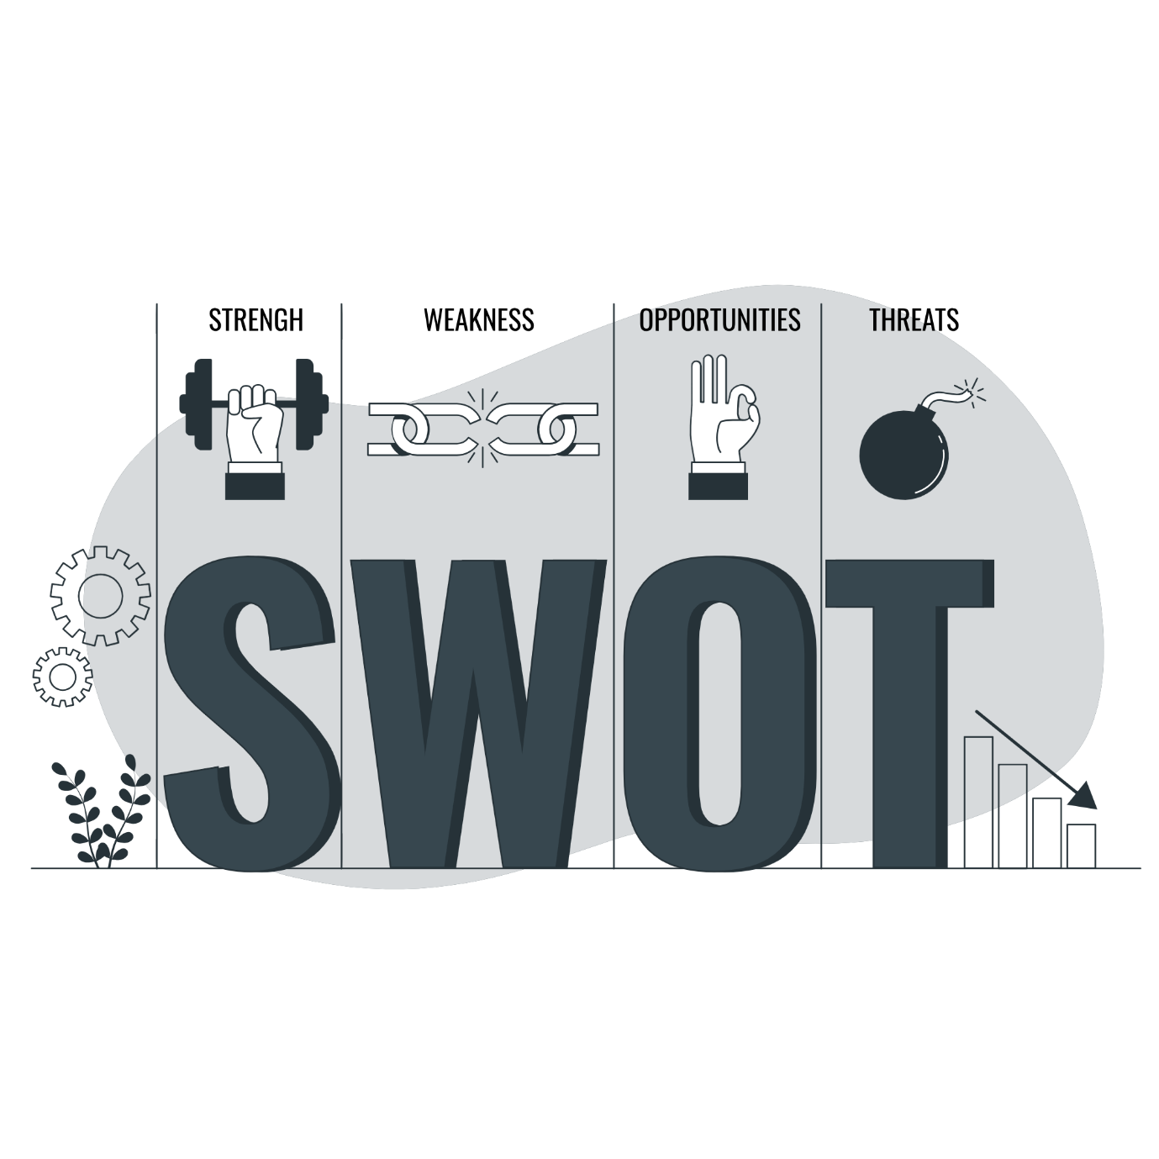

## Swot Analysis for Visor Insurance

### Strengths

1. Reputation: Visor Insurance has a long-standing reputation dating back to the 1960s, which can be leveraged to build trust with customers and stakeholders.
2. Large Customer Base: With over 4 million customers, Visor Insurance possesses a substantial client base, providing a strong foundation for growth and revenue generation.
3. Skilled Workforce: The company employs 1500 employees, including Claims Representatives and Insurance Underwriters who specialize in various insurance areas, ensuring expertise in handling customer needs.
4. Diverse Product Portfolio: Offering both personal and business insurance products diversify the revenue streams, reducing dependency on a single market segment.
5. Efficient Claims Handling: Claims Representatives use the Claims Management Information System (CMIS) to process claims, potentially leading to faster and more accurate claims handling.

(Fine, 2016)

### Weaknesses

1. Outdated Information System: The current information system, last overhauled in 2014, faces problems such as data breaches and data accuracy issues. It may not fully align with current business needs.
2. Data Security Concerns: The recent data breach and reported data protection issues highlight vulnerabilities in data security practices.
3. Inconsistent Data Entry: Not all CSAs consistently update the CMIS after customer contact, leading to inaccuracies, loss of data, and incomplete records.
4. Customer Complaints: Feedback from customers indicates dissatisfaction with the usability of the online account section, potentially affecting customer retention.
5. Limited Market Share in Business Insurance: Despite plans for expansion, Visor Insurance's market share in business insurance stands at 15%, indicating a need to improve in this segment.

(Fine, 2016)

### Opportunities

1. New Information System: The need for a modern, integrated Information System presents an opportunity to enhance efficiency, security, and customer satisfaction.
2. Market Expansion in Business Insurance: Increasing the market share in the profitable business insurance segment from 15% to 40% could significantly boost the company’s revenue.
3. Compliance with Legislation: Adapting to recent government changes in personal insurance legislation can ensure compliance and mitigate regulatory risks.
4. Improved Data Handling: Addressing data security concerns and inconsistent data entry can enhance customer trust and reduce data protection issues.
5. Enhanced Customer Experience: Improving the online account section based on customer feedback can lead to higher satisfaction and retention rates.

(Fine, 2016)

### Threats

1. Data Breaches and Privacy Concerns: Continued data breaches and privacy issues can lead to legal actions, loss of trust, and reputational damage.
2. Competitive Market: The insurance industry is highly competitive, with both established players and new entrants. Maintaining a competitive edge is challenging.
3. Regulatory Changes: Frequent changes in insurance regulations can pose compliance challenges and impact operational processes.
4. Employee Stress and Turnover: Inaccurate data and customer complaints may contribute to employee stress and high turnover rates.
5. Technology Advances: Rapid technological advancements may require continuous investment to stay up-to-date, posing financial challenges.

(Fine, 2016)

In summary, Visor Insurance's strengths include its reputation, customer base, skilled workforce, product portfolio, and efficient claims handling. However, weaknesses related to the outdated information system, data security, inconsistent data entry, customer complaints, and limited market share in business insurance need addressing. Opportunities lie in system upgrades, market expansion, compliance, data handling improvements, and enhanced customer experience. Threats encompass data breaches, competition, regulatory changes, employee issues, and evolving technology. A strategic plan should leverage strengths, mitigate weaknesses, seize opportunities, and prepare for threats to ensure long-term success.

(Fine, 2016)

## Technical factors from weaknesses and threats

### Weaknesses

1. Outdated Information System: The existing information system, which was last updated in 2014, presents a significant vulnerability in terms of technology, impairs functionality, exposes sensitive information, and has difficulty adapting to the changing demands of the business.



Recommendation: Invest in a comprehensive system upgrade or replacement. This involves modernizing your software, strengthening security measures, and ensuring scalability to accommodate a larger customer base and new legal regulations.

1. Data Security: Visor Insurance's reputation and customer trust are under serious threat due to the recent concerns about data protection and a breach of data.



Recommendation: Implement a robust cybersecurity framework, including encryption, access controls, regular security audits, and employee training on data handling best practices. Hire or consult with cybersecurity experts to establish and maintain strong security protocols.

(Kleppmann, 2017)

1. Inconsistent Data Entry: Inaccuracies, data loss, and incomplete records may result from CSAs who do not regularly update the Claims Management Information System (CMIS) following customer contact.



Recommendation: Develop user-friendly, intuitive data entry interfaces within the new information system. Implement data validation checks and reminders to encourage complete and accurate data entry. Provide training and incentives to encourage compliance.

(Kleppmann, 2017)

1. Customer Complaints: The usability problems in the online account section, as revealed by customer feedback, have adversely affected customer satisfaction.



Recommendation: Conduct user experience (UX) research and usability testing to identify issues in the online account section. Use the findings to redesign the interface, making it more intuitive and user-friendly. Continuously gather feedback from users for improvements.

(Kleppmann, 2017)

### Threats

1. Data Breaches and Privacy: Legal actions, loss of trust, and reputational damage may result from persistent privacy concerns and data breaches.



Recommendation: Continuously monitor for vulnerabilities and invest in threat detection and response systems. Develop an incident response plan to mitigate the impact of potential breaches. Comply with data protection regulations to minimize legal risks.

(Kleppmann, 2017)

1. Technology Advances: To stay current with fast-changing technology, ongoing investment may be necessary, which could present financial and technical obstacles.



Recommendation: Develop a plan for technology implementation that involves timely updates and the adoption of innovative technologies when suitable. Set aside a portion of the budget for research and development to ensure that the company stays ahead in the technological arena.

(Kleppmann, 2017)

In addressing these technical weaknesses and threats, Visor Insurance should focus on a comprehensive strategy that includes upgrading technology, implementing strong cybersecurity measures, and training employees. They should also keep up with regulations and prioritize making customer experiences better, all while ensuring long-term success in the ever-changing insurance industry.

(Kleppmann, 2017)

# Task 4 – User Requirements & Design (25 marks)

(25 marks)

## Claim Representatives Analysis

### Characteristics and Requirements



1. Knowledge:

* Claims Representatives must have a good understanding of insurance policies, coverage, and claim handling procedures.
* They should be familiar with different types of claims, such as property damage, personal injury, or liability claims.
* Claims Representatives should be comfortable using various software and tools for claim evaluation, documentation, and communication.
* They should be able to utilize the Claims Management Information System (CMIS) effectively.

(Paul, et al., 2014)



1. Analytical Skills:

* Claims Representatives need strong analytical skills to assess the validity and liability of claims.
* They should be able to review documents, gather relevant information, and make informed decisions based on policy, terms and conditions.

(Paul, et al., 2014)



1. Customer Service:

* Claims Representatives should possess excellent customer service skills to handle customer inquiries, address concerns, and provide support during the claims process.
* They must be able to communicate with customers, gather necessary information, explain claim processes, and provide updates throughout the claims handling process.
* They should be empathetic, patient, and able to handle difficult situations professionally.
* Collaborative communication with Customer Service Advisors (CSAs) is necessary for data accuracy.

(Paul, et al., 2014)



1. Attention to Detail:

* Claims Representatives must pay close attention to detail to accurately evaluate claims, review policy information, and document claim details.
* A small oversight can lead to inaccuracies or delays in processing claims.

(Paul, et al., 2014)



1. Time Management:

* Given the high volume of claims, Claims Representatives need strong time management skills to prioritize tasks, meet deadlines, and ensure timely resolution of claims.
* Prioritizing urgent claims while maintaining consistency in processing is vital.

(Paul, et al., 2014)



1. Problem-Solving:

* Claims Representatives should be skilled in problem-solving to handle complex claims, resolve disputes, and make fair claim decisions.
* They may need to consult experts or conduct additional research to gather necessary information.

(Paul, et al., 2014)

### Hierarchical Task Analysis

The below diagram showcases the tasks involved when Claims Representatives handle online submitted claims.

## New Customer Account Interface

This new modern user interface will help customers to easily view and make changes to their Visor Insurance account.

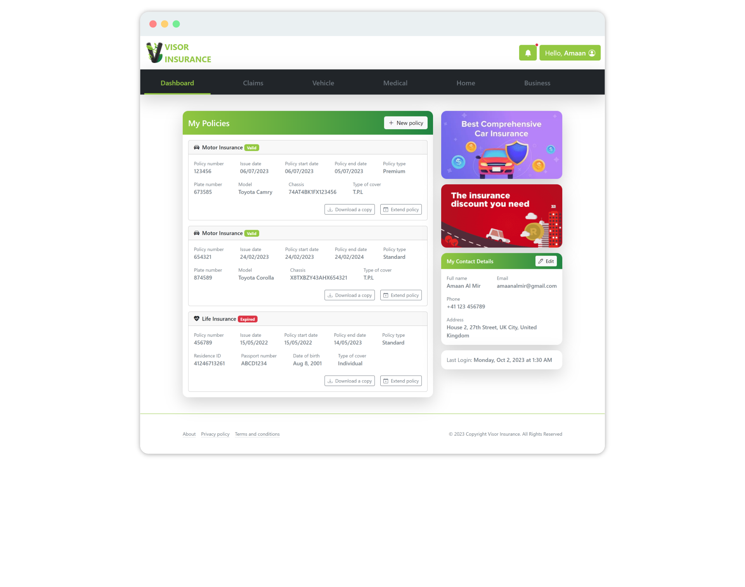

[Click here](profile.html) to open this in a browser (requires internet connection).

This is the first page the customer will see after logging into their account. It shows an overview of the policies they hold with Visor Insurance and their contact details. It also displays some special offers, the date and time of last login and notifications of any new messages the customer receives.



Special Offers

Customer Policies

Last Login

Contact Details

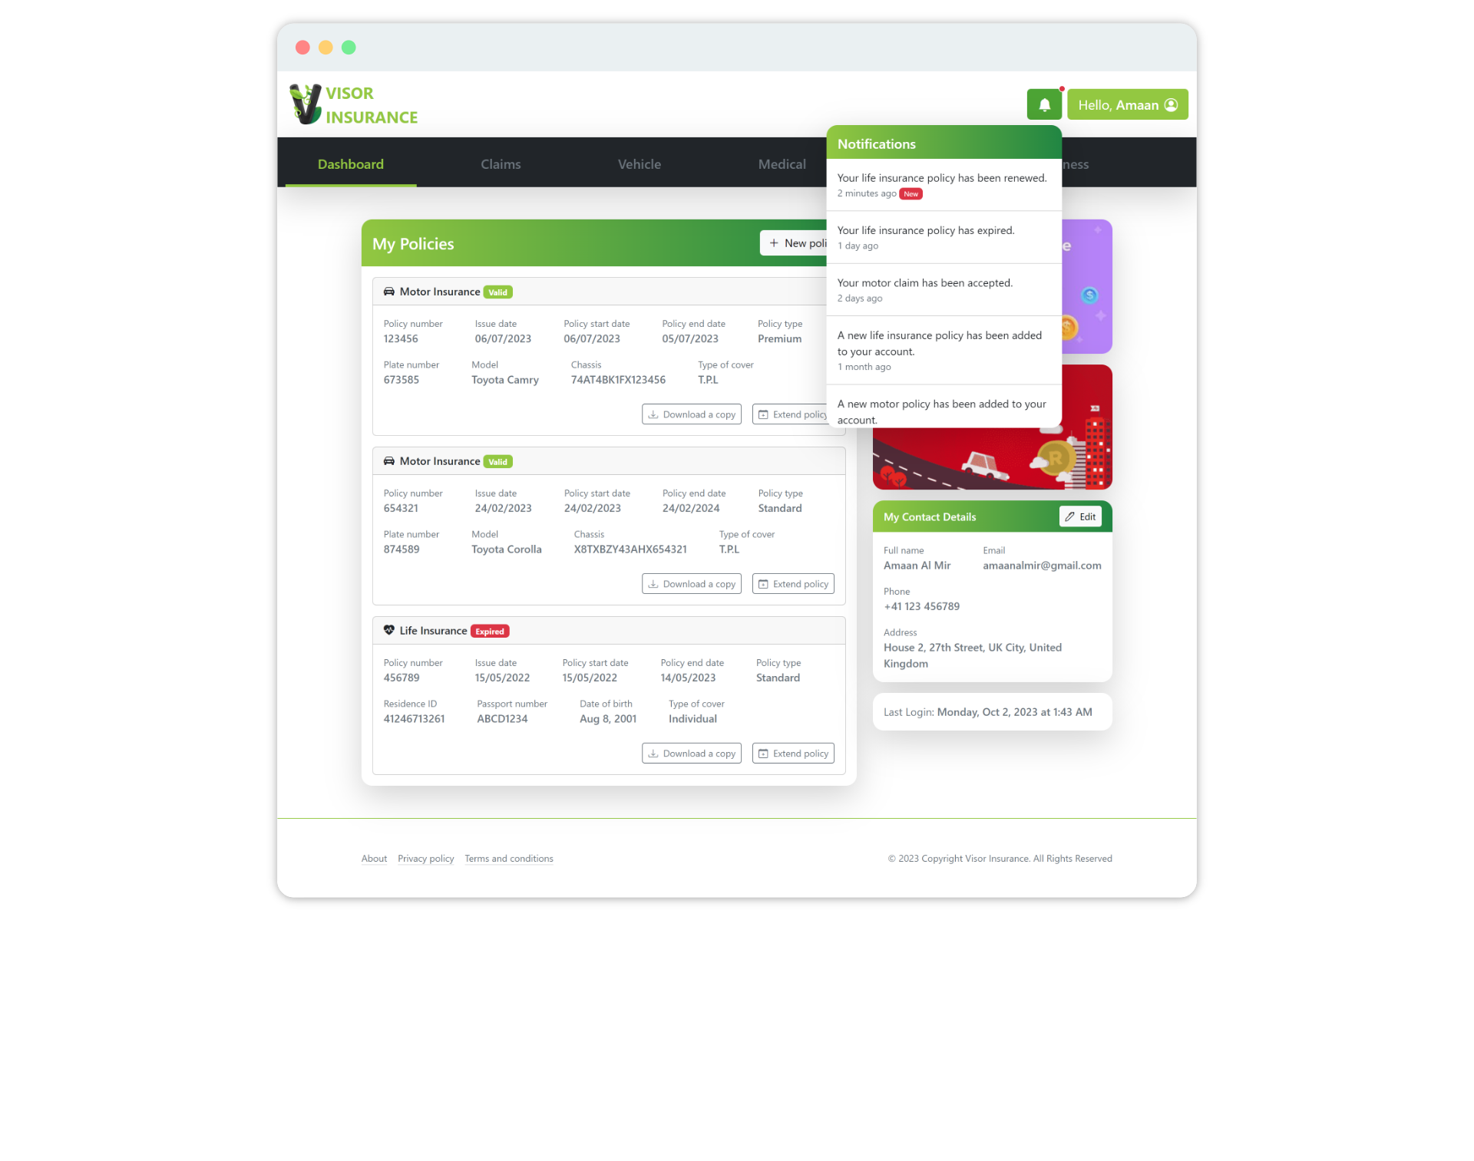

Edit buttons

Notifications

This new interface design for the customer account profile page ensures ease-of-use and customer satisfaction.

# Task 5 (10 marks)

Based on the Rolfe, G., Freshwater, D., and Jasper, M. (2001) model for critical reflection, I’m reviewing my learning by answering “What?”, “So What?”, and “Now What?” questions of the process and providing a clear action plan for future improvements.

## Description

Completing this assignment has been a valuable learning experience. It required a deep understanding of the provided scenario, the ability to apply various analysis techniques, and the skill to present information in a clear and organized manner.

(Rolfe, et al., 2001)

## Analysis

1. Scenario Analysis: Understanding the provided scenario was the foundational step. It involved extracting critical information, identifying stakeholders, and comprehending the business environment. This process helped me grasp the context and align my responses with the scenario.
2. Ethical Questions: Writing the ethical questions was a valuable learning experience. It emphasized the significance of ethical considerations, human factors, and user-centered design in system development.
3. SWOT Analysis: Conducting the SWOT analysis required critical thinking to identify the strengths, weaknesses, opportunities, and threats facing Visor Insurance. It highlighted the importance of assessing both internal and external factors.
4. Hierarchical Task Analysis: Creating the hierarchical task analysis helped break down complex processes into manageable steps. This approach facilitated a systematic understanding of the tasks performed by Claims Representatives.
5. New Interface Design: The new UI design for customers was challenging as I had to take design principles, modernization and ease-of-use of the system into consideration without failing to miss any given requirement. However, with the help of tools like Bootstrap, I was able to efficiently design the page and implement all listed requirements.

(Rolfe, et al., 2001)

## Action Plan

Ultimately, I successfully completed all the given tasks, but to improve the process, I require an expert level of knowledge and experience in Information Systems Analysis.

However, there are still some improvements I can think of applying in the future.

1. Enhance Scenario Analysis: In future assignments, I will focus on extracting even more details from the scenario to ensure a deeper understanding. This will involve looking for implicit information and connections.
2. Refine SWOT Analysis: I will aim to provide more specific and actionable recommendations in the SWOT analysis, connecting identified factors to potential strategies for improvement.
3. Task Analysis Clarity: When conducting the hierarchical task analyses, I will ensure each step is clearly defined and logically structured, making it easier for readers to follow the process.
4. User-Centered Design: The UI design model has reinforced the importance of considering user perspectives in system design. In future assignments, I will consistently apply user-centered design principles, emphasizing empathy for users' needs and concerns.
5. Continual Learning: To enhance my learning, I will actively seek additional resources and methodologies related to information systems analysis, staying updated on best practices in the field.

(Rolfe, et al., 2001)

This critical reflection and action plan highlight the areas where my learning process can be improved and how I can apply these improvements in future assignments to produce more comprehensive, insightful, and user-centric analysis.

# References

Fine, L. G., 2016. *The SWOT Analysis: Using Your Strength to Overcome Weaknesses, Using Opportunities to Overcome Threats.* 4th ed. s.l.:Prentice Hall.

Kleppmann, M., 2017. *Designing Data-Intensive Applications.* 1st ed. s.l.:O'Reilly Media, Inc..

Paul, D., Cadle, J. & Yeates, D., 2014. *Business Analysis.* 3rd ed. s.l.:BCS Learning & Development Limited.

Rolfe, G., Freshwater, D. & Jasper, M., 2001. *Critical Reflection for Nursing and the Helping Professions: A User's Guide.* Basingstoke: Palgrave Macmillan.

Satzinger, J. W., George, J. & Davis, K. S., 2020. *Systems Analysis and Design in a Changing World.* 9th ed. s.l.:Cengage Learning.

Valacich, J. W. & George, J. F., 2022. *Ethics in Information Systems.* 10th ed. s.l.:Pearson.